Helpsheet ACC_001
Accessible learning: Remote teaching considerations.
This helpsheet details advice around inclusive teaching practice when teaching remotely. With the transition to remote teaching, now is a critical time to ensure the technical accessibility of learning resources.

Inclusive remote-teaching practice
Inclusive teaching practice should consider the range of potential barriers to learning that students might face. These may come from disabilities (intellectual, physical, mental health, sensory), or may be socio-economic barriers such as the space/hardware to study from home.
An inclusive approach to remote-teaching should consider these barriers when designing learning activities, and also ensure the technical accessibility of resources (e.g. alt text, correct formatting, etc.). If you are unsure of how to address a technical accessibility challenge; providing alternative formats is usually the simplest approach.
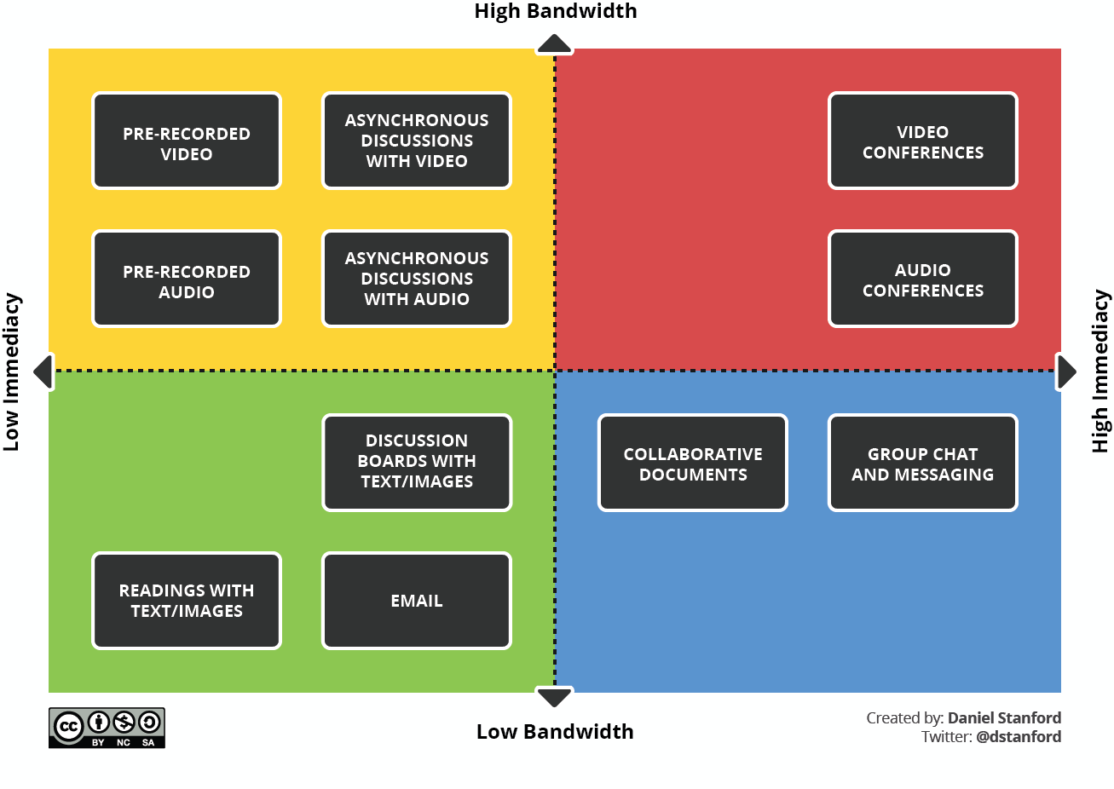
Figure 1: Learning resources that are used asynchronously may be more inclusive as they lower the demand on hardware/bandwidth and allow more flexibility for students. Synchronous resources should be used strategically to reinforce engagement with other learning materials.

Creating accessible documents with Microsoft Office
Many Office 365 apps include an Accessibility Checker that finds accessibility problems and lists suggestions, or you can find specific tips for making your content accessible to all. See a 1 minute video on how to use the accessibility checker here.

Top 10 tips for accessibility
The 10 tips outlined here are strongly recommended for all staff as quick and simple reminders of important accessibility elements: Access ’10 quick tips for easily creating more accessible content’ (PDF)

Inclusive presentations
When presenting PowerPoint presentations; live, for recordings (via Panopto), or online (via Collaborate), it is possible to use a live subtitling service built into PowerPoint in the web.
See the guidance for using live subtitles here: Helpsheet ACC_002 - Live subtitles with PowerPoint (PDF).

Further resources
- For training on effective use of the Microsoft Office suite to create more accessible documents: Access a 25 minute LinkedIn Learning course.

- Microsoft also offer training on creating more accessible content in Outlook, Word, Excel and PowerPoint; Access the Microsoft Accessibility training.

- For support on creating a more inclusive environment for learning and supporting students with special educational needs; Access the Dyslexia Awareness course(opens in a new tab) from Made by Dyslexia.

