Helpsheet ACC_002
Live subtitles with PowerPoint
This helpsheet details advice around presenting from PowerPoint in the web, to use the live subtitles function.

- Ensure that your PowerPoint presentation is stored in your OneDrive.
- Navigate to Office.com (using Chrome) and sign in to your account.
- Open your presentation in the web version of PowerPoint
- Under ‘Slideshow’ in the top menu, select ‘Always use subtitles’ and select the option ‘Below slide’
- Start your presentation by clicking either ‘From Beginning’ or ‘From Current Slide’. You will see the subtitles appear as you speak. You can speak at your normal pace, the subtitle services captions sentences at a time.

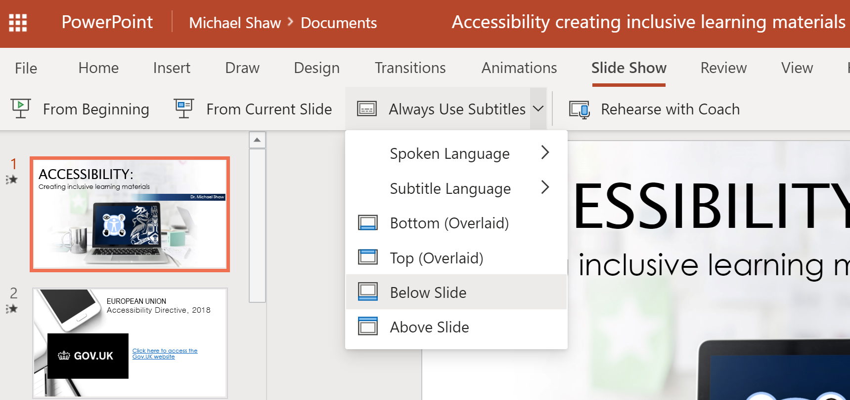
Screenshot 1: PowerPoint in the web, showing the ‘Slideshow’ settings for subtitles.

Additional information:
If you are presenting online via Collaborate Ultra; remember to share your screen rather than upload your PowerPoint file to Collaborate.

If you are recording a video via Panopto; remember to capture the main screen (or secondary screen as appropriate), rather than use the ‘capture PowerPoint’ feature.
