Remote teaching Advice for Staff

In the event of disruption to normal service staff are still able to run classes as scheduled using Digital tools. Here’s what to do.
Decide how you want to deliver the class. You have two options:

- You can deliver the class live via Blackboard Collaborate, or
- Deliver the class as a pre-recorded podcast using Panopto. Students can access the recording on-demand.

If delivering live, Blackboard Collaborate is the tool to use. If delivering a pre-recorded podcast, Panopto Desktop is the better option.

How to deliver a live class using Blackboard Collaborate

First, if you are not familiar with Blackboard Collaborate take a look at this helpsheet which details the capabilities of the tool.

CO_001 - What Is Blackboard Collaborate Ultra | Doc | PDF | Video
C0_007 - Getting Started with Collaborate Ultra Video

Then, you need to make Collaborate Ultra available on the module site.

CO_002 - Making Collaborate Ultra Available on a Module Site | Doc | PDF

Enter the Collaborate Ultra room and familiarise yourself with the functionality.

CO_003 - Joining a Collaborate Ultra Room | Doc | PDF
CO_005 - Functionality and Sharing Content in Collaborate Ultra | Doc | PDF
C0005 - Live Chat and Breakout Rooms Using Collaborate Ultra | Video

Send an Announcement to students advising how to join the Collaborate room and when the session starts. Direct your students to the student-facing help materials on Collaborate in Bb Help and Support.

CO_004 - Recording a Collaborate Ultra Session | Doc | PDF | Video

Additional resources:

CO_006 - Accessing Collaborate Ultra Recordings and Sharing the Link | Doc | PDF

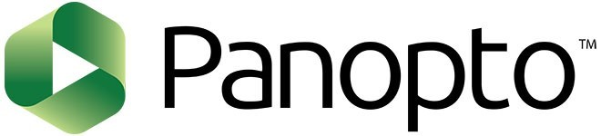

How to create and distribute a pre-recorded podcast to your students:

First you need to configure the Panopto folder on your Bb module site:

PO_002 - Configuring a Panopto Folder on a Blackboard Module Site | Doc | PDF

Then, you need to install Panopto Desktop on the machine you will be using and to start the recording. When you click Create you are presented with an option to download and Install Panopto. Panopto works on both Macs and PCs:

PO_011 - Recording on your computer using Panopto | Doc | PDF

When the recording is done, you just need to send an Announcement to students that the video is available on the Panopto area on the Bb module site.

Additional resources:

PO_001 - What Is Panopto | Video
PO_008 - Embedding Panopto Video Into a Module Site | Doc | PDF

