Remote teaching - Advice for Students

In the event of temporary disruption to normal teaching, we aim to minimise the impact to your studies. Your tutors may still run classes as scheduled. Do look out for Announcements.

The class may be delivered live by Blackboard Collaborate or for you to watch on-demand or as a recorded lecture via Panopto. Here’s what to do for both options.

How to access recordings on Panopto

The video can be accessed on the Bb module site by clicking the Panopto button on the menu bar.

POS_005 - Viewing content on a module | PDF | Doc

Additional resources:

POS_001 - What is Panopto? | PDF | Doc

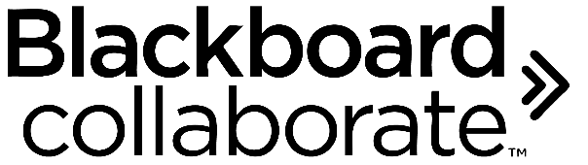

How to access a live Collaborate session on Bb

First, if you are not familiar with Blackboard Collaborate take a look at this helpsheet which details the capabilities of the tool.

COS_001 - What is Blackboard Collaborate Ultra? | PDF | Doc

You can join the session by going to the Blackboard Collaborate area on the Bb module site.

COS_002 - Joining a Collaborate Ultra session and interacting with other students | PDF | Doc

