Helpsheet TE_001
Student presentations and posters for assessment: A remote working solution
This helpsheet details advice around using Teams to manage student presentation assessments whilst working remotely.

This guide offers a remote delivery/online solution to handling student presentation or poster assessment events.

The typical formats for this assessment usually involves one student (or small groups) presenting content (generally a PowerPoint, poster, or physical object) to either a small group of tutors and/or fellow students, followed by a Q&A session. Marking and feedback may take place immediately, or shortly after the presentation. This document offers advice on how to replicate this assessment experience online using Microsoft Teams.

How to:

Set expectations and give clear briefing: As with all transitions to remote teaching, the more you communicate with your students the better.

Initiate a chat message with the student and add additional students and/or tutors. A check-in message 5-10 minutes in advance of the presentation would work well: “Hi [student] are you ready to start your presentation in 5 minutes? Please share the file with us here too so that we have a copy.”

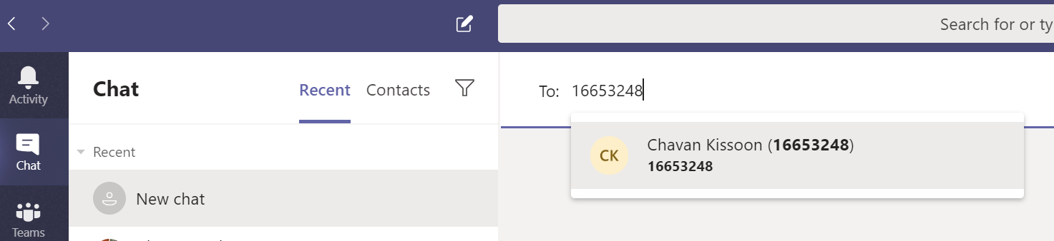
Screenshot 1: New chat screen.
When everyone is ready, start a group call using the calling option icons in the top right of the screen, check webcams and microphones where appropriate.

Screenshot 2: Calling option icons (Left to right): Start video call, Start audio call, Start sharing your screen, Add people.

Ask (one) student to share their screen or camera and present, if groups are presenting, one student shares the screen content and the others can all enable microphones to talk. Tutors can enable their microphone to ask questions. Tutors can discuss the marks/feedback in a separate, private conversation.

Screenshot 3: in call icons (left to right): Time on call, enable/disable webcam, enable/disable microphone, Share content, Additional options, Show conversation, Show participants, End call.

Technical requirements
Each student and staff member will need a computer with internet connection and a microphone, (webcam optional).

All participants should download the Teams desktop (or mobile) app. If joining via a browser; Chrome should be used. (Download Teams from Microsoft here.)

Preparing staff
Staff should download and test out chat and calling features with colleagues to build confidence in using the software.

The lead member of staff should have a collated list of who is presenting, when, and to whom to facilitate the calling.

Extra time should be allowed for initiating the call and orientating through the initial set up, an approximate additional 50% time allowance could be built in. A 10-minute presentation with 5 minutes of questions should be allocated a time slot of ~22.5 minutes

Preparing students
Students should be encouraged to download and test the software well in advance of the assessment. Students can test the features with each other and can even practice their presentations to their peers.

The presentation schedule should be arranged and distributed so that students are aware of timings.

Additional Considerations
Technical resilience: It is important to accept when working remotely that internet connections and computers may cause complications. Patience, resilience and open communication are crucial to working online.
Adjustments to marking criteria: Depending on the assessment, it may be useful to revisit the assessment criteria to reduce weighting on criteria such as ‘presentation confidence’.

Additional information
Quick start guide to Teams: PDF Download: Teams Quick Start Guide.
Teams demo: Online guided demo of Teams.

