OneDrive and Email Submissions of Assessed Work
This helpsheet will guide you through the process of submitting your assessed work via OneDrive and emailing a link to your school.

- Save your file with an appropriate filename; we recommend [Module code]+[student ID]+filename.. e.g. ‘ABC1234M-1920_012345678_TCAsubmission’

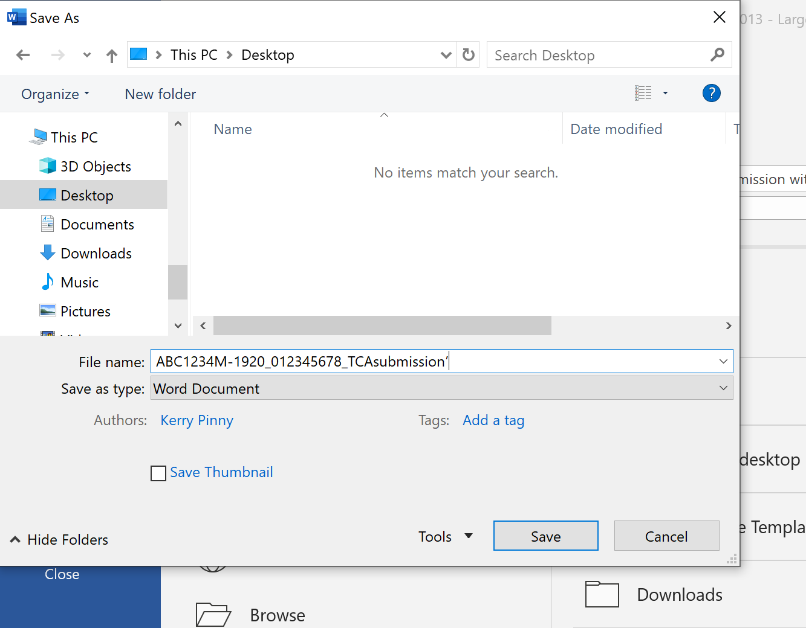

- Navigate to 365.lincoln.ac.uk and sign in with your University credentials.

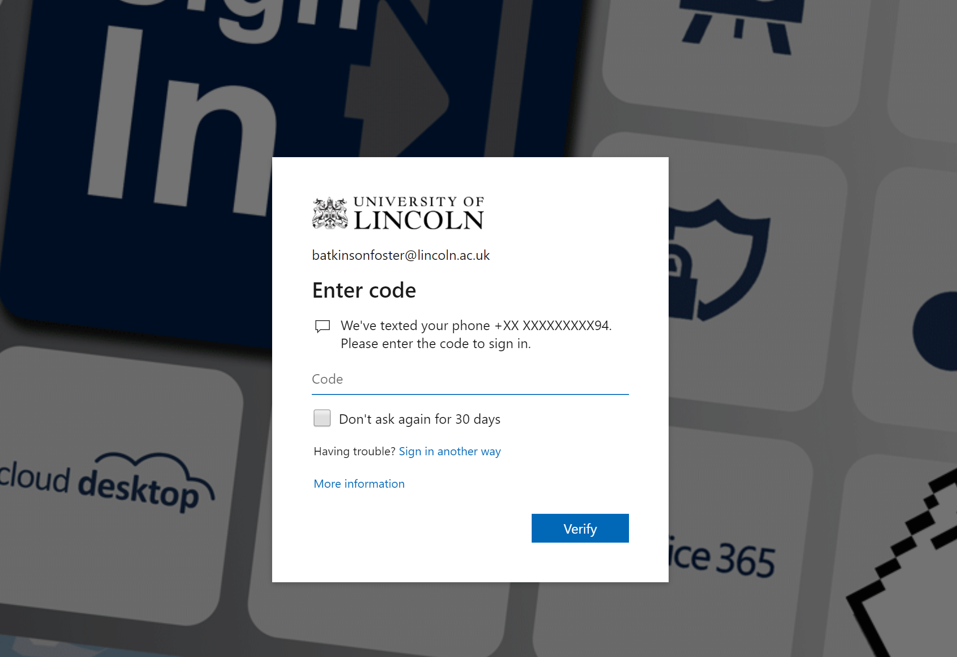

- Click on ‘OneDrive’ from the list of apps

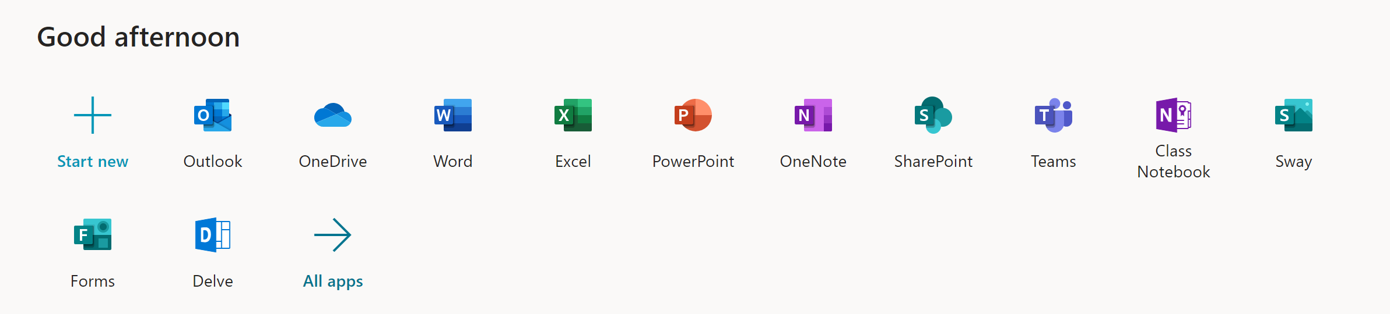

- Click ‘Upload’ and then ‘Files’ and select your TCA submission document

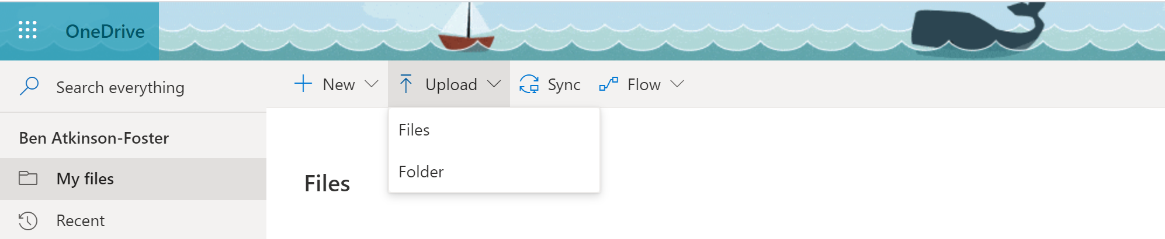

- Once upload is complete open the document to check that the correct version is uploaded.

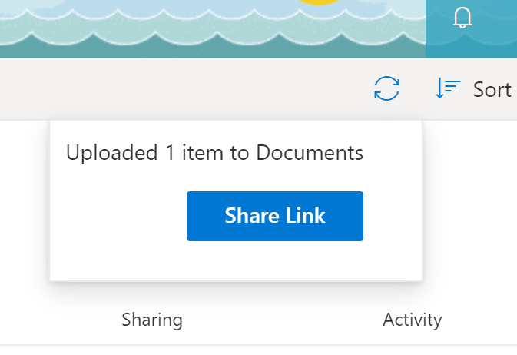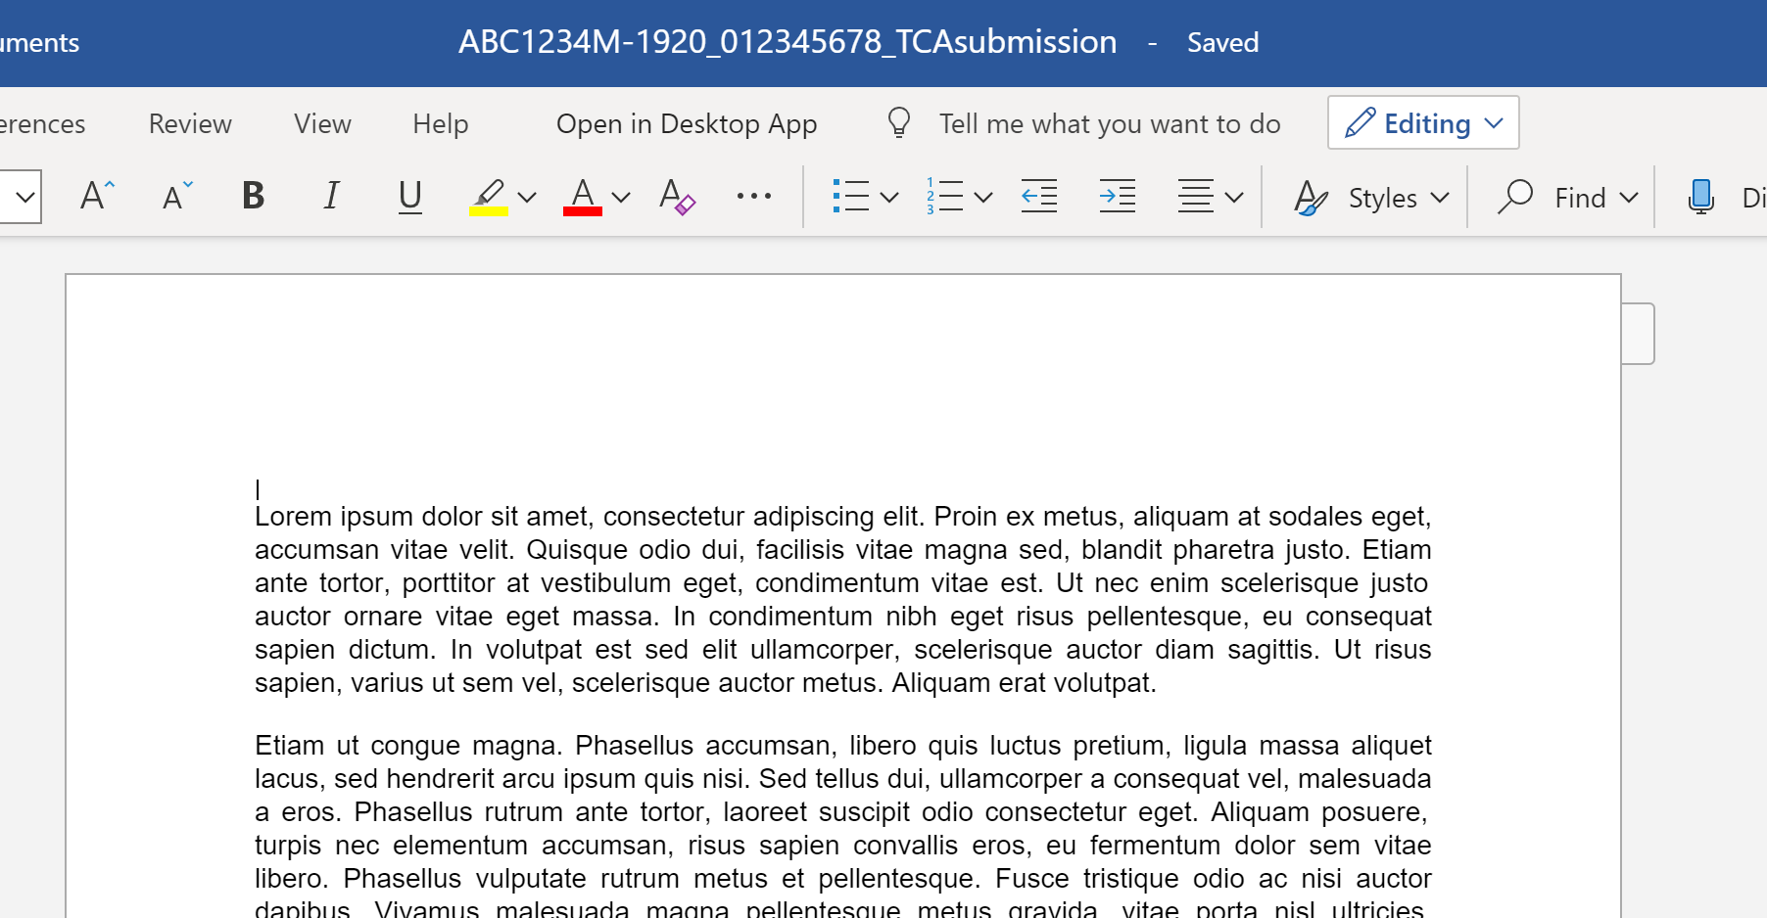

- In OneDrive, click on the ellipses (three dots) next to the file and click ‘Share’.

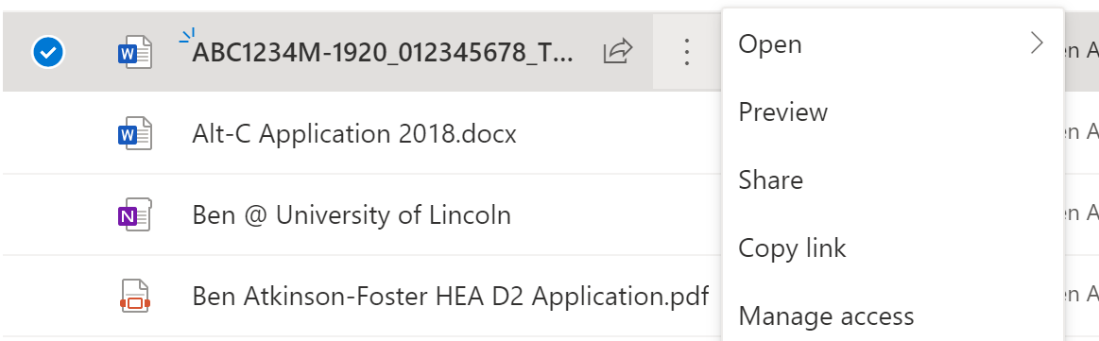

- Click on the share setting ‘People you specify can view’ and change this option to ‘People in the University of Lincoln with the link’. Do not tick the ‘allow editing box’ and make sure that you do not have the ‘Block download’ option selected, then click ‘Apply’.

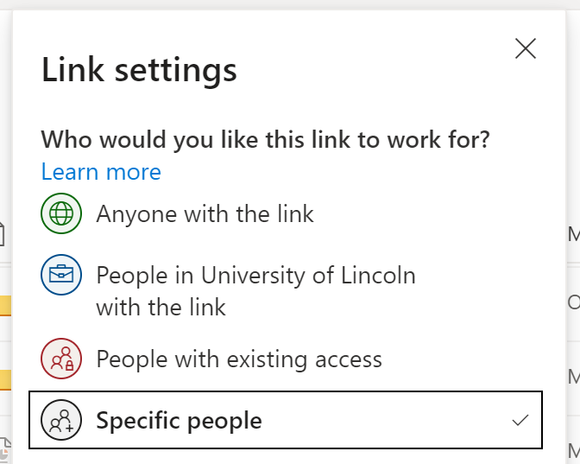

- In the field; ‘Enter a name or email address’ enter your School’s submission inbox.

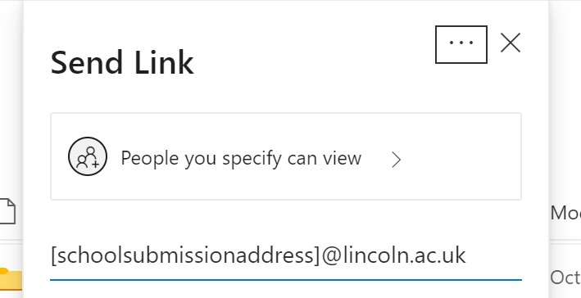

- Add a message if you wish. This is recommended and we suggest you follow this approach: This is my submission for [assessment name] on [module code] my student ID is [student ID].

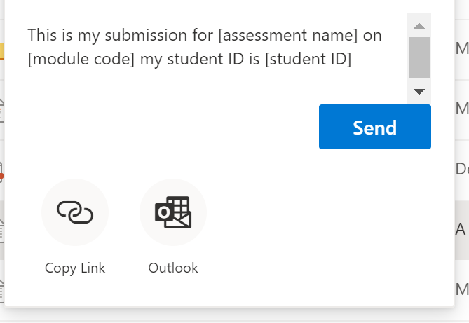

- Click ‘Send’

- You will receive an automatic reply from the School Submissions email confirming your submission.

NOTE: Changes post submission are recorded and students should NOT access the file once submitted.

