Helpsheet RA_001
Conducting Time Constraint Assessments (TCA) and Short Format Assignments using Turnitin
This helpsheet details the steps involved in conducting Time Constraint Assessments (TCA) and Short Format Assignments using Turnitin.

How this helpsheet differs from the existing helpsheets

This helpsheet is specifically for those modules with Time Constraint Assessments (TCA) and Short Format Assignments. This guide should be used alongside other guidance provided by your college or the university.

Benefits of using Turnitin

Turnitin has academic integrity functions built in. The Similarity Checker allows for students’ submitted work to be checked against Turnitin’s database for similarity matches, which can be an indicator of potential plagiarism. Authorship Investigate is designed to combat the rise in contract cheating by providing universities with an evidence gathering tool.

Steps

A visual representation of the steps involved appears below.

Getting the Adaptive Release and Post Date settings exactly correct is of the utmost importance in order to prevent questions being released early or later, and results being released ahead of time.

Step 1: Hiding the Total column in Grade Centre

To remove the possibility of grade leakage, you need to ensure the Total Column is hidden in Grade Centre.

- Go to Full Grade Centre on your Blackboard site and hide the Total Column by clicking the chevron next to Total.

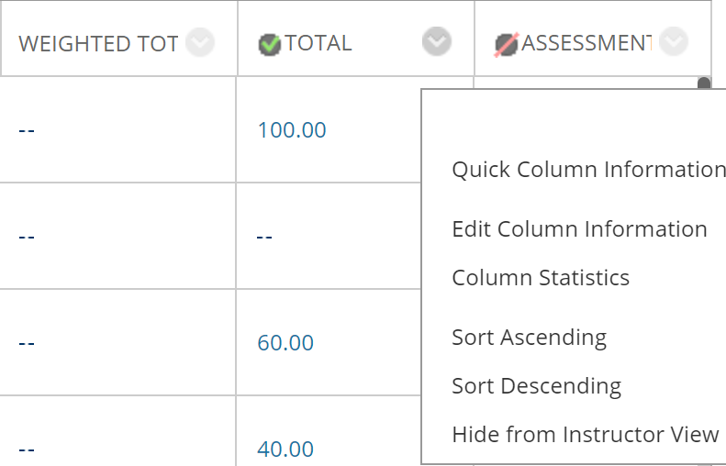

- On the next screen, scroll down to the Options section. Change Show this Column to Students to No. Settings should be as in the image below. Click Submit.

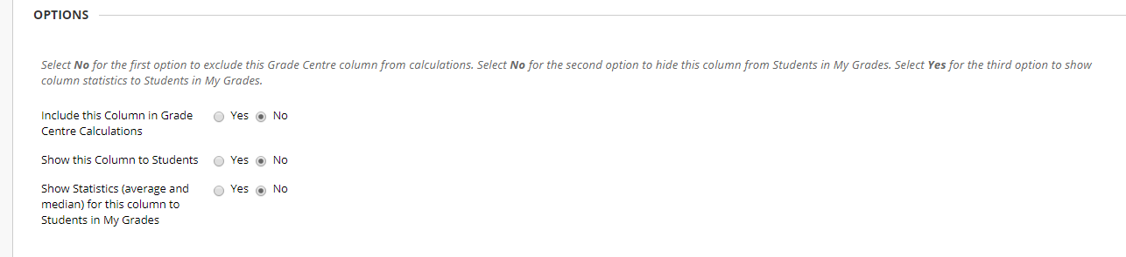

- The column should now look like this with a red line next to a green tick.

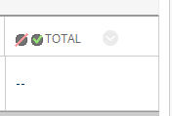

Step 2: Adding a Content Item with detailed Exam Instructions

- In the Assessments area of your Bb site, create a Content Item by clicking Build Content and Item.

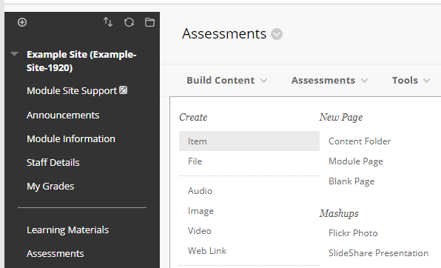

- Add text to the boxes marked below. Attach any relevant documents and add the rubric for the Time Constraint Assessments (TCA) or Short Format Assignments. Ensure the Select Date and Time Restrictions are accurate. Click Submit when done.
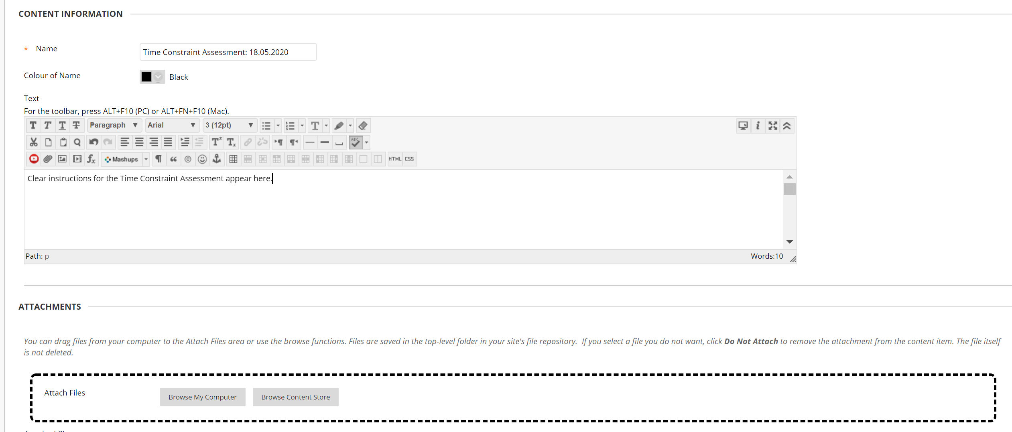

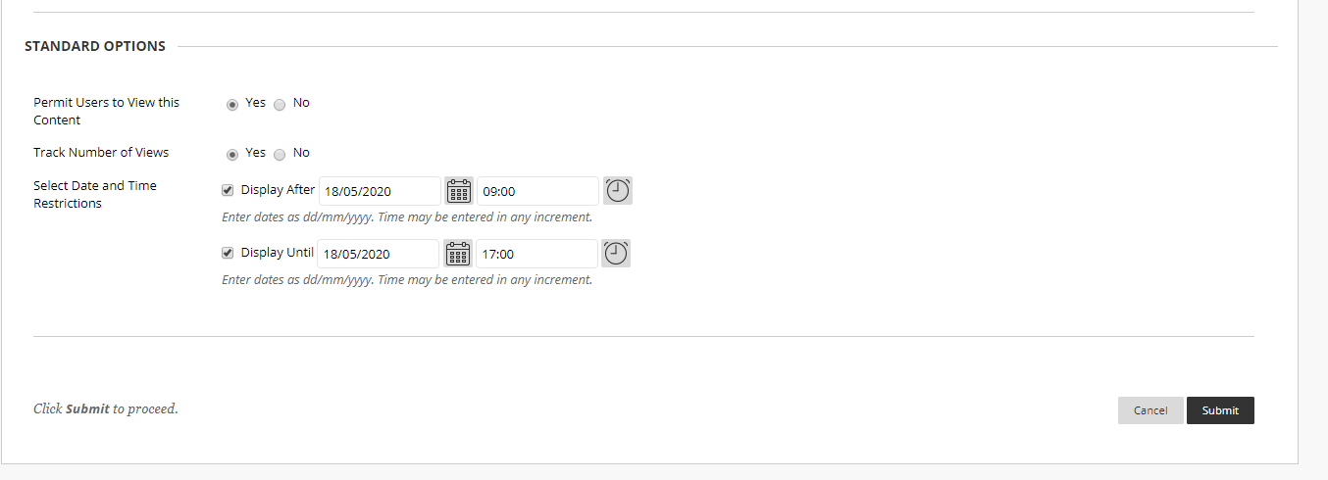

- The Content Item should look something like this.

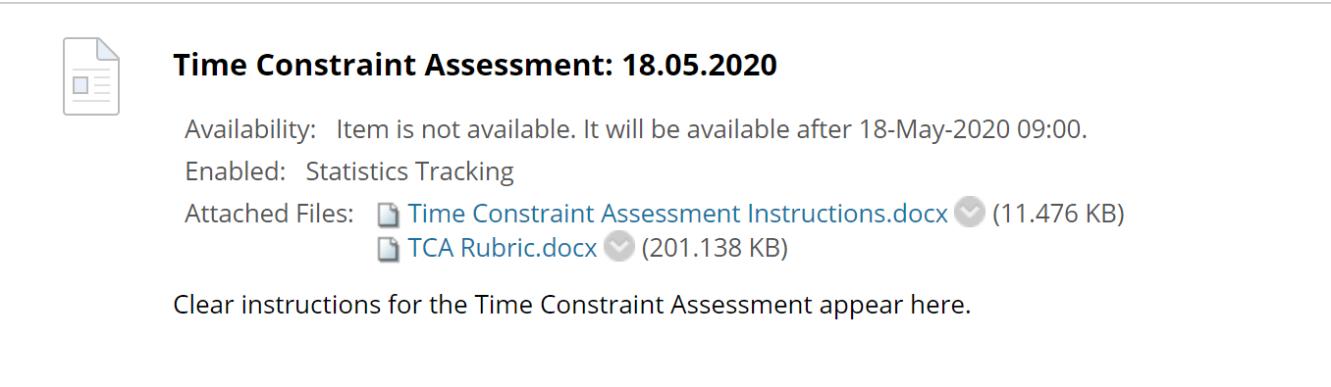
Now, you need to create a Turnitin submission point.

Step 3: Creating a Turnitin submission point

- Go to the Assessments area of the Bb site. This differs by School BB template. A selection are shown below.

- Click on the Assessments tab along the top of the area and choose Turnitin Assignment.

- For a standard submission point choose Paper Assignment and click Next Step.

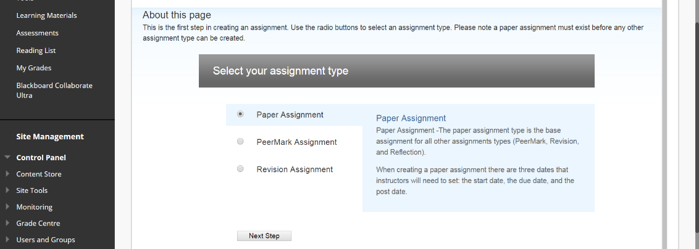

- Give your Assignment title a name. If a Time Constraint Assessment, the name should be in the format: Time Constraint Assessments - Due [insert date and time]. If a Short Format Assignments, the name should be in the format: Short Format Assignments - Due [insert date and time]

- Point value refers to the score you want to mark out of. This nearly always should be 100.

- Start date refers to when the submission point will be available to accept submissions. This should be the start time of the Time Constraint Assessment/Short Format Assignment and needs to match existing guidance provided by your school, college or the university (e.g. over how it aligns to the existing exam timetable).

- Due date refers to the hand in date for the students. This should be as per UoL guidance for Time Constraint Assessments/Short Format Assignment. Pay particular attention to the Time settings.

- Post date refers to the day the results and any feedback will be made available to the students. This should be in line with guidance you have received from the university. Pay particular attention to the Time settings.

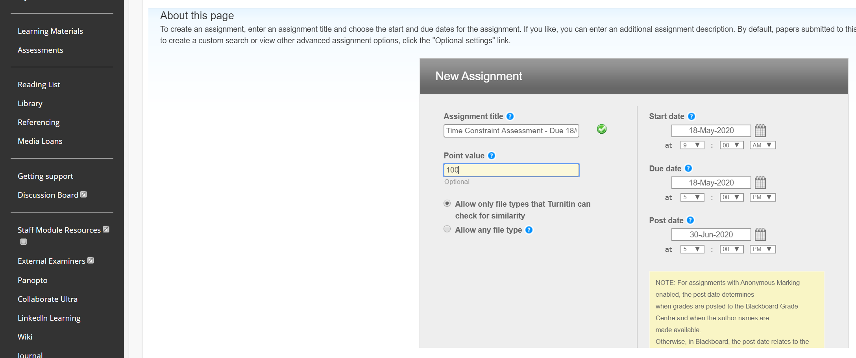

- Click Optional Settings to open up some important settings (N.B. these settings need to be looked at).

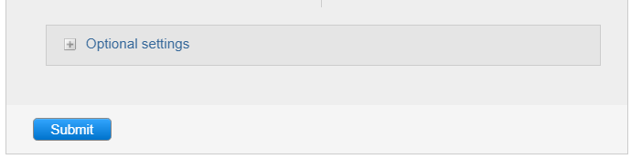

- Hover the mouse cursor over the blue circle icon at the end of each section for a full description on that option.

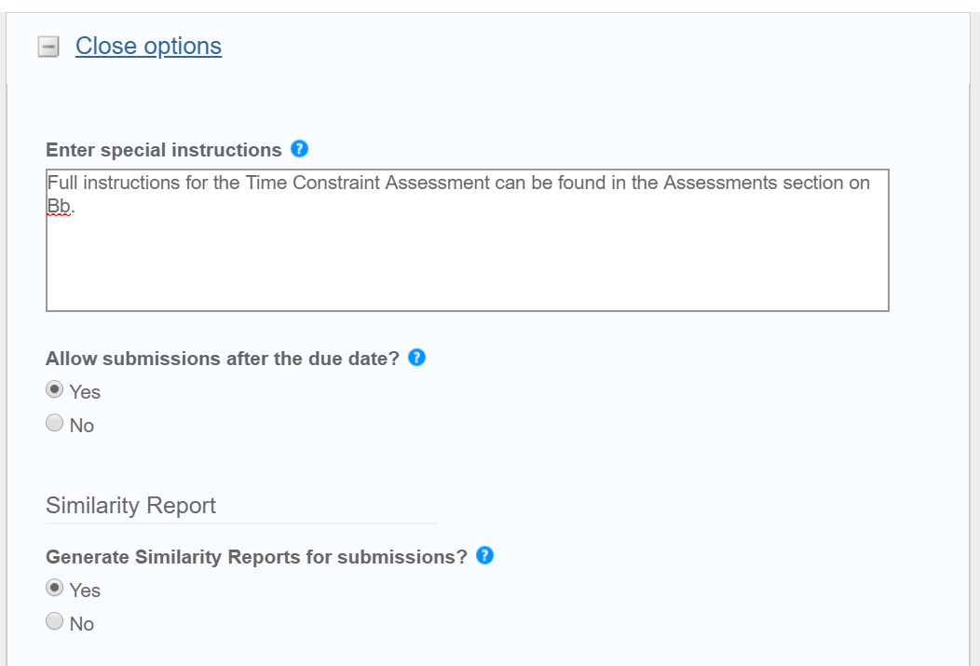

Important Note:

- Reveal grades to students only on post-date, should be set to YES. Otherwise, the grades will be revealed to all students as soon as you enter them.
- Allow students to see Originality Reports should be set to No.

- It is recommended that the settings should be as detailed below. Each setting is now explained in turn.

- Submissions should be allowed after Due Date. Late submissions will be marked in red. Penalties can be applied as per UoL procedures.
- Similarity Reports should be set to Yes in order to enable UoL’s Academic Integrity processes.
- Immediately should be selected for the next option. This allows students to resubmit multiple times before the deadline.
- Exclude Bibliography ought to be set to No to ensure standardisation across UoL.
- Exclude Quoted materials ought to be set to No to ensure standardisation across UoL.
- Exclude Small sources should be set to No.
- Students should not be allowed to see similarity reports in order to reduce the amount of potential issues (delays from Turnitin in processing reports, students not realising only one report can be generated per day for each assignment point).
- Reveal Grades should be set to Yes to avoid grade leakage.
- Seek advice from HoS regarding Anonymous Marking settings if unsure.
- Papers should be submitted to the Standard Repository.
- All should be ticked for Search Options.

- Click Submit when you are happy with all the options.

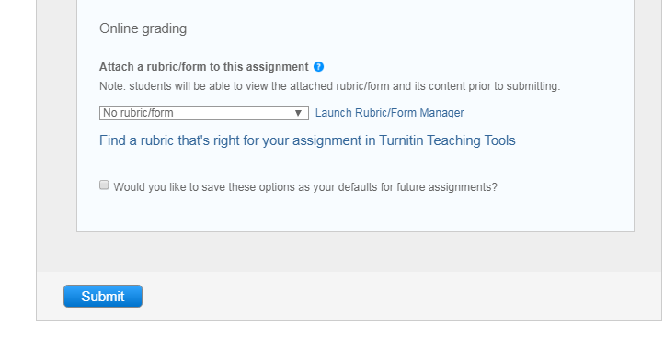

- The submission point is then created. Click OK to go back to the assignments content area. The Turnitin submission point you just created will be placed at the bottom of the content in the content area.

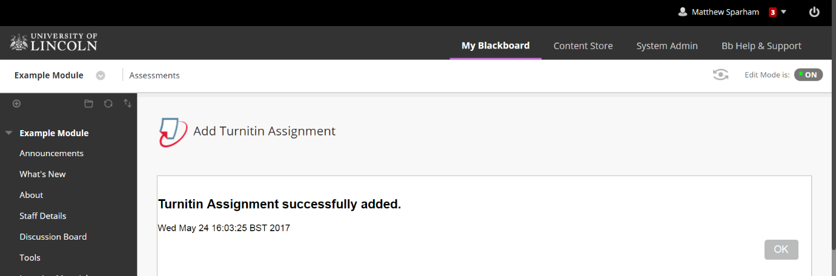

Conclusion

You should now be ready to run your Time Constraint Assessments (TCA) or Short Format Assignment on Turnitin.
Do ask a colleague to check your setup is as settings need to be correct in order to reduce the possibility of issues
on the day such as early/late release of questions and early/late release of feedback.

For further advice, contact the Digital Education team.

